**Bus Ticket Booking and Pass System**

**Submitted In partial fulfilment of the requirements for the degree**

**Of**

**BACHELOR OF SCIENCE**

***In***

**COMPUTER APPLICATION &INFORMATION TECHNOLOGY**

***By***

**Shah Sharvil Piyushbhai (2133068)**

**Khatri Jeet Gautamkumar (2133194)**

**Thakkar Avnish Vinodchandra (2133242)**

***Group No. 14***



**K.S. SCHOOL OF BUSINESS MANAGEMENT**

**Gujarat University Campus,**

**Navrangpura, Ahmedabad -380009**

**ACKNOWLEDGEMENT**

# We wish to express our heartfelt appreciation to all those who have contributed to this project, both explicitly and implicitly, without the co-operation of whom, it would not have been possible to complete this project.

We would like to thank our institute for giving us the opportunity to have some feel about the competitive environment. We would like to thank our **all our faculties** for constantly guiding and showing us the correct path to reach towards our desired goal.

We are indebted and thankful to all people for their keen interest, untiring perseverance and unceasing motivation during the course of our project despite of their busy schedule.

Last but not the least we would like to thank our family members and friends for their constant encouragement and support throughout the duration of our project.

**Shah Sharvil (2133068)**

**Khatri Jeet (2133194)**

**Thakkar Avnish (2133242)**

|  |  |  |  |  |
| --- | --- | --- | --- | --- |
| **No** | **Table Of Contents** | | | **Page No** |
| **1** | **Company Profile** | | | **04** |
| **2** | **Project Profile** | | | **05** |
|  | **2.1** | | **Project Definition** |  |
|  | **2.2** | | **Current System** |  |
|  | **2.3** | | **Proposed System** |  |
| **3** | **System Requirement And Specification** | | | **06** |
| **4** | **System Design** | | | **07** |
|  | **4.1** | **Activity Diagram** | |  |
|  | **4.2** | **Use Case Diagram** | |  |
|  | **4.3** | **Sequence Diagram** | |  |
|  | **4.4** | **Class Diagram** | |  |
|  | **4.4** | **Data Dictionary** | |  |
| **5** | **Input-Output Design(Screen Shoats)** | | | **23** |
| **6** | **Testing** | | | **37** |
| **7** | **Future Scope, Limitation** | | | **42** |
| **8** | **Conclusion** | | | **43** |
| **9** | **Bibliography** | | | **44** |

**INDEX**

**1. Company Profile**

**DSYN HUB**professional 3D design company providing design and animation solutions for companies or individuals interested in outsourcing their design and animation activity.**TC DSYN HUB** is a design and animation company based at Ahmadabad (India) having younger start up A 4 year young company. Our design and animation services serve our client with excellent quality at cost effective price within deadline period. Our experience designing team using updated technologies to build any types project. We deliver high quality design solutions and services through our motivated and qualified specialist teams which are focused on exceeding client’s expectations every time.

**We have the key capabilities in the fields of:**

* **Web Development**
* **Research & Market Analysis**
* **Offshore Development**
* **QA outsourcing**
* **Networking**

**We have dedicated professionals in following areas,**

* **JQuery Mobile**
* **Android**
* **PHP**
* **.NET**
* **Java**

We are dealing with all types of client including corporations, individual professionals, and non-profit groups, businesses of all size, government contractors, IT firms, and advertising agencies.

**Address:** 806, Supath, 2nd Floor, Aeon Complex, Opposite Memnagar Fire Station, Vijay Char Rasta, Sarvottanagar Society, Navrangpura, Ahmadabad, Gujarat 380009

**Phone:** 079 4004 4008

**2. Project Profile**

**2.1 Project Definition**

In this website people can book the ticket of Bus anywhere anytime and also they can

Create Pass from website.

**2.2 Current System**

* People need to ask for schedule or have to visit particular place.
* People have To book ticket manually
* Pass is manually obtained

**2.3 Proposed System**

* People can see schedule Anytime Any Where
* People can Book, Cancel ticket and Select seat/s
* People can get Pass Online

**3. System Requirement and Specification**

**3.1 Hardware Requirement**

Processor : Minimum Pentium

RAM : 256 MB or More

**3.2 Software Requirement**

Web Browser

**3.3Technology Used**

***3.3.1Frontend Technology***

* + - JSP-Servlet:
    - HTML5:
    - CSS:
    - JQUERY:
    - Java Script:

***3.3.2Frontend Tools:***

* Dreamweaver CS6
* Photoshop CS6
* Eclipse
  + 1. ***Backend Technology***
* MySQL

**3.3.4 Backend Tools**

* + MySQL
    1. **Web server**
  + Apache Tomcat 7

**System Design**

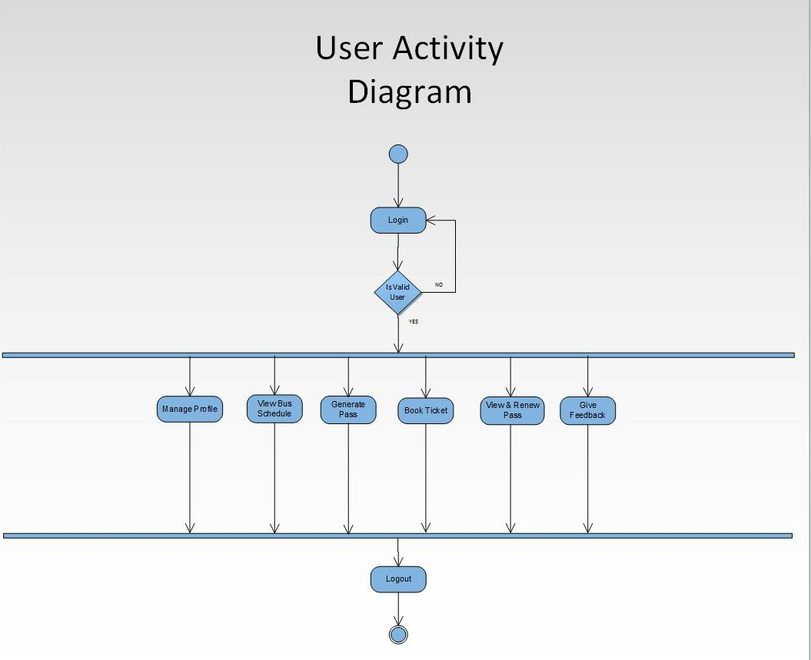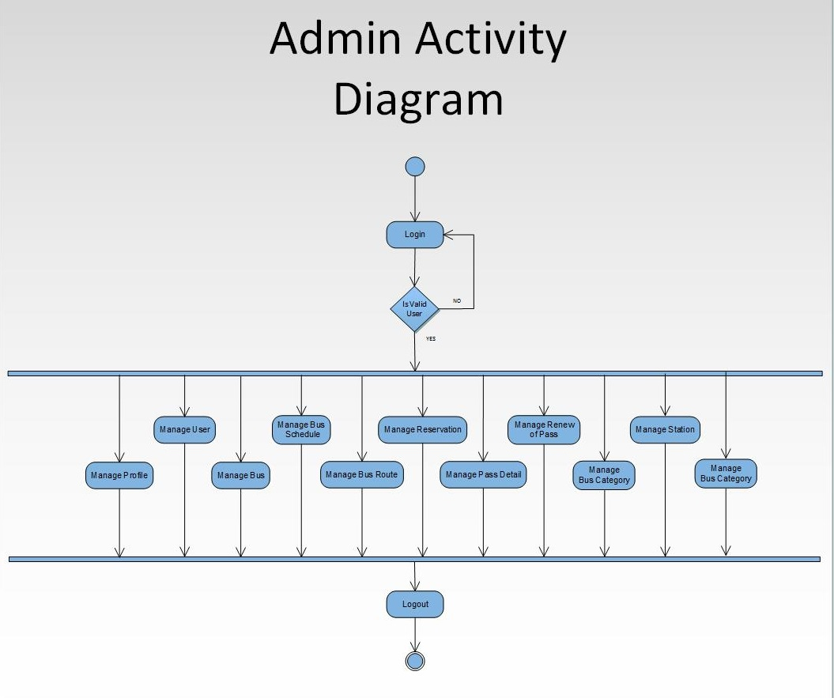

**4. System Design**

**User case :**

**For admin:**

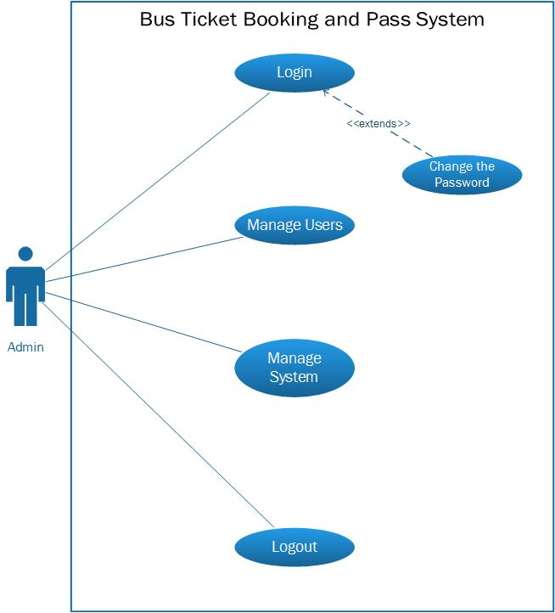

**For User:**

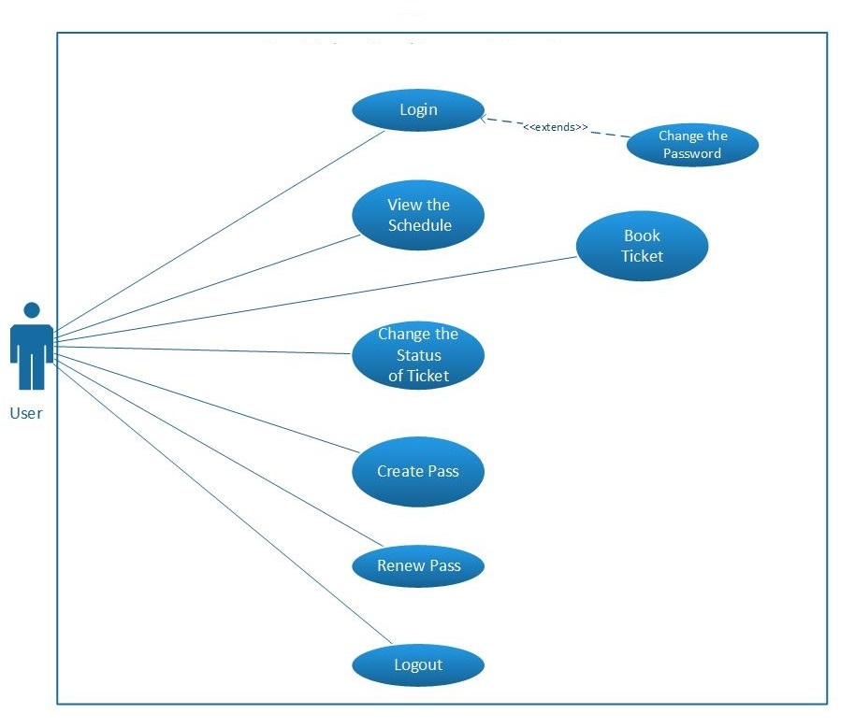

**SEQUENCE Diagram:**

**For admin:**

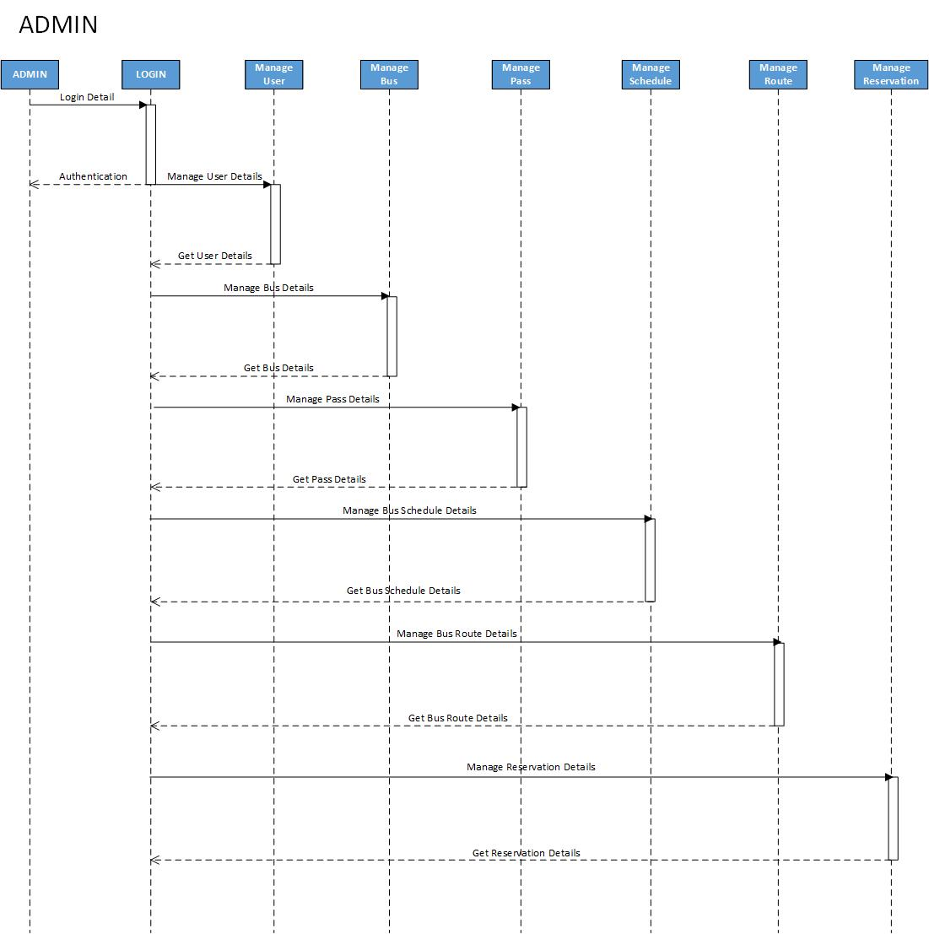

**For User:**

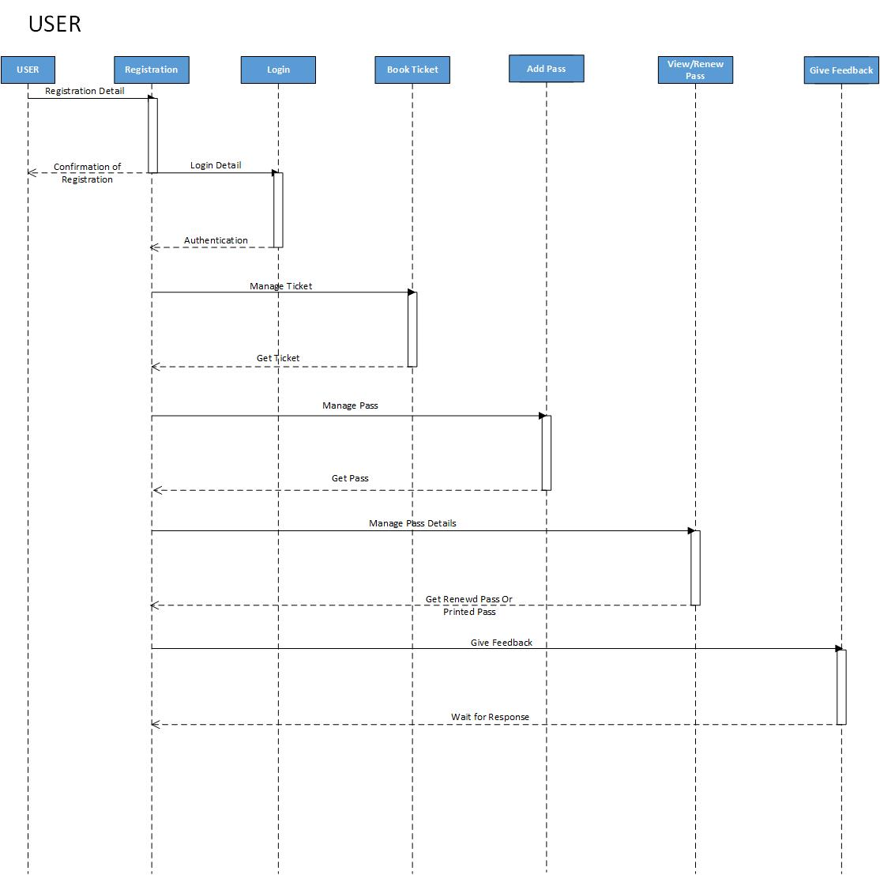

**Class Diagram:**



**DATA DICTIONARY**

**Table No 1**

**Table Name: User**

|  |  |  |  |  |
| --- | --- | --- | --- | --- |
| Field Name | DataType | Field Length | Constraints | Description |
| UserId | Int | 10 | Primary Key, auto increment | User id |
| FirstName | Varchar | 15 | Not null | First Name of User |
| MiddleName | Varchar | 15 | Not null | Middle Name of User |
| LastName | Varchar | 15 | Not Null | Last Name of User |
| Email | Varchar | 30 | Unique, Not null | User Email id |
| Password | Text | - | Not null | Encrypted password for user login |
| MobileNo | Varchar | 10 | Not null | User mobile number |
| Gender | Char | 1 | Not null | User gender |
| CityId | Int | 5 | Foreign Key | From City table |
| Address | Varchar | 50 | Not null | User Address |
| IsActive | Char | 1 | Not null,default=”y” | User active or not |

**Table No: 2**

**Table Name: Route**

|  |  |  |  |  |
| --- | --- | --- | --- | --- |
| Field Name | Data Type | Field Length | Constraints | Description |
| RouteId | Int | 5 | Primary key ,auto increment | Id of route |
| SourceId | Int | 5 | Foreign key | From Station Table[StationId] |
| DestionationId | Int | 5 | Foreign key | From Station Table[StationId] |
| IsAvalible | Char | 1 | Not null | Is route available or not |

**Table no: 3**

**Table Name: Pass**

|  |  |  |  |  |
| --- | --- | --- | --- | --- |
| Field Name | Data Type | Field Length | Constraints | Description |
| PassId | Int | 5 | Primary Key,auto increment | Pass id |
| UserId | Int | 10 | Foreign key | From user table |
| PassTypeId | Int | 2 | Foreign key | From Pass Type table |
| SourceId | Int | 5 | Not null | From station table [StationId] |
| DestinationId | Int | 5 | Not null | From station table [StationId] |
| Photo | Text | - | Not null | Photo of passholder |
| OrgId | Int | 5 | Foreign key | From organization table |
| StartTermDate | Date | - | - | Start term date |
| EndTermDate | Date | - | - | End term date |
| TermValidity | Int | 1 | Not null | Term validity in months |

**Table no: 4**

**Table Name: Pass type**

|  |  |  |  |  |
| --- | --- | --- | --- | --- |
| Field Name | Data Type | Field Length | Constraints | Description |
| PassTypeId | Int | 2 | Primary key,auto_ increment | Pass type id |
| PassType | Varchar | 7 | Not null | Pass type |

**Table No: 5**

**Table Name: Pass Detail**

|  |  |  |  |  |
| --- | --- | --- | --- | --- |
| Field Name | Data Type | Field Length | Constraints | Description |
| PassId | Int | 5 | Foreign key | From table Pass |
| StartDate | Date | - | Not null | Starting date of pass |
| EndDate | Date | - | Not null | Ending date of pass |
| Validity | Int | 1 | Not null | Pass validity |
| Amount | Int | 5 | Not null | Total pass amount |

**Table No: 6**

**Table Name: Organization**

|  |  |  |  |  |
| --- | --- | --- | --- | --- |
| Field Name | Data Type | Field Length | Constraints | Description |
| OrgId | Int | 5 | Primary key, auto increment | Organization ID |
| OrgName | Varchar | 30 | Not null | Organization name |
| OrgAddress | Varchar | 50 | Not null | Organization Address |

**Table No: 7**

**Table Name: City**

|  |  |  |  |  |
| --- | --- | --- | --- | --- |
| Field Name | Data Type | Field Length | Constraints | Description |
| CityId | Int | 5 | Primary key,auto increment | City id |
| CityName | Varchar | 30 | Not null | City name |

**Table No: 8**

**Table Name: Reservation**

|  |  |  |  |  |
| --- | --- | --- | --- | --- |
| Field Name | Data Type | Field Length | Constraints | Description |
| ReservationId | Int | 5 | Primary key ,auto increment | Reservation id |
| UserId | Int | 10 | Foreign key | From User Table |
| SourceId | Int | 5 | Foreign key | From Station Table[StationId] |
| DestinationId | Int | 5 | Foreign Key | From Station Table[StationId] |
| TotalAmount | Int | 5 | Not null | seats*distance*0.8 |
| NoOfSeat | Int | 1 | Not null | How many seats user want |
| ResDate | Date | - | Not null | Reservation date |
| BusNo | Varchar | 12 | Foreign key | From bus table |
| JouneyDate | Date | - | Not null | Journey date |
| isCancel | Char | 1 | Not null ,default=’n’ | Is booking cancelled or not |
| Distance | Int | 5 | Not null | Distance in km |

**Table no: 9**

**Table Name: ReservationDetail**

|  |  |  |  |  |
| --- | --- | --- | --- | --- |
| Field Name | Data Type | Field Length | Constraints | Description |
| ReservationId | Int | 5 | Foreign key | From Reservation Table |
| SeatNo | Int | 2 | Foreign key | Seat no |
| SeatTypeId | Int | 2 | Not null | From SeatType table |

**Table No: 10**

**Table Name: Admin**

|  |  |  |  |  |
| --- | --- | --- | --- | --- |
| Field Name | Data Type | Field Length | Constraints | Description |
| AdminId | Int | 5 | Primary key,auto increment | Admin id |
| FirstName | Varchar | 15 | Not null | Admin First Name |
| MiddleName | Varchar | 15 | Not null | Admin Middle Name |
| LastName | Varchar | 15 | Not null | Admin last Name |
| Email | Varchar | 255 | Not null | Admin Email |
| CityId | Int | 5 | Foreign key | From City Table |
| Email | Varchar | 30 | Unique, Not null | Admin email |
| Password | Varchar | Text | Not null | Encrypted password for admin login |
| Address | Varchar | 255 | Not null | Admin Address |
| Mobile No | Varchar | 10 | Not null | Admin Contact No |
| IsActive | Char | 1 | Not null,default=”y” | Admin active or not |

**Table No: 11**

**Table Name: Bus**

|  |  |  |  |  |
| --- | --- | --- | --- | --- |
| Field Name | Data Type | Field Length | Constraints | Description |
| BusNo | Varchar | 12 | Primary key | Bus number |
| BusTypeId | Varchar | 7 | Foreign key | From BusType table |
| Capacity | Int | 3 | Not null | Capacity of bus |
| IsAvailable | Char | 1 | Not null,default=’y’ | Bus availability |
| BusCategotyId | Int | 2 | Foreign key | From table BusCategory |
| BusDepoId | Int | 5 | Foreign key | From table City[CityId] |

**Table No: 12**

**Table Name: Schedule**

|  |  |  |  |  |
| --- | --- | --- | --- | --- |
| Field Name | Data Type | Field Length | Constraints | Description |
| ScheduleId | Int | 5 | Primary key,auto_incerment | Schedule id |
| BusDetailId | Int | 5 | Foreign key | From Bus Detail table |

**Table No: 13**

**Table Name: Station**

|  |  |  |  |  |
| --- | --- | --- | --- | --- |
| Field Name | Data Type | Field Length | Constraints | Description |
| StationId | Int | 5 | Primary key, Auto increment | Station id |
| StationName | Varchar | 15 | Not null | Station Name |
| CityId | Int | 5 | Foreign key | From City table |

**Table No: 14**

**Table Name: Feedback**

|  |  |  |  |  |
| --- | --- | --- | --- | --- |
| Field Name | Data Type | Field Length | Constraints | Description |
| FeedbackId | Int | 5 | Primary Key,auto_increment | Feedback id |
| UserId | Int | 10 | Foreign Key | From User Table |
| Feedback | Text | - | Not null | Feedback from User |

**Table No: 15**

**Table Name: Seat Type**

|  |  |  |  |  |
| --- | --- | --- | --- | --- |
| Field Name | Data Type | Field Length | Constrains | Description |
| SeatTypeId | Int | 2 | Primary Key,auto_increment | Seat id |
| SeatType | Varchar | 10 | Not null | Seat type |

**Table No: 16**

**Table Name: Bus Type**

|  |  |  |  |  |
| --- | --- | --- | --- | --- |
| Field Name | Data Type | Field Length | Constraints | Description |
| BusTypeId | Int | 1 | Primary key ,auto increment, | Bus type id |
| BusType | Varchar | 10 | Not null | Bus type |

**Table No: 17**

**Table Name: Bus Category**

|  |  |  |  |  |
| --- | --- | --- | --- | --- |
| Field Name | Data Type | Field Length | Constraints | Description |
| BusCategoryId | Int | 1 | Auto increment, primary key | Bus category id |
| BusCategoty | Varchar | 10 | Not null | Bus Category Name |

**Table no: 18**

**Table Name: Bus Detail**

|  |  |  |  |  |
| --- | --- | --- | --- | --- |
| Field Name | Data Type | Field Length | Constraints | Description |
| BusDetailId | Int | 5 | Auto increment, primary key | Bus Detail id |
| BusNo | Varchar | 12 | Foreign key | Bus number |
| RouteId | Int | 5 | Foreign key | From Route table |
| IsAvailable | Char | 1 | Not null,default=’y’ | availability |

**Table No: 19**

**Table Name: Schedule details**

|  |  |  |  |  |
| --- | --- | --- | --- | --- |
| Field Name | Data Type | Field Length | Constraints | Description |
| ScheduleId | Int | 5 | Foreign Key | Schedule id |
| SourceId | Int | 5 | Foreign key | From Station Table[StationId] |
| DestinationId | Int | 5 | Foreign key | From Station Table[StationId] |
| DepartureTime | Time | - | Not null | Departure time of bus |
| WeekOffDay | Int | 1 | - | Weekend day at which bus will not come |
| OffDate | Date | - | - | Date which bus will not come |
| ArrivalTime | Time | 5 | Not null | Arrival time |
| TimeTaken | Int | 5 | Not null | Reach time in min |
| Distance | Int | 5 | Not null | Distance between source and destination |

**Table No: 20**

**Table Name: Logs**

|  |  |  |  |  |
| --- | --- | --- | --- | --- |
| Field Name | Data Type | Field Length | Constraints | Description |
| LogId | Int | 5 | Primary key | Log id |
| UserName | Varchar | 50 | Not null | User Name |
| UserType | Varchar | 7 | Not null | Admin or User |
| LoginTime | Varchar | 50 | Not null | Login time |
| LogoutTime | Varchar | 50 | Not null | Logout Time |

**INPUT-OUTPUT**

**DESIGN**

**5. Input-Output Design**

**Index Page:**

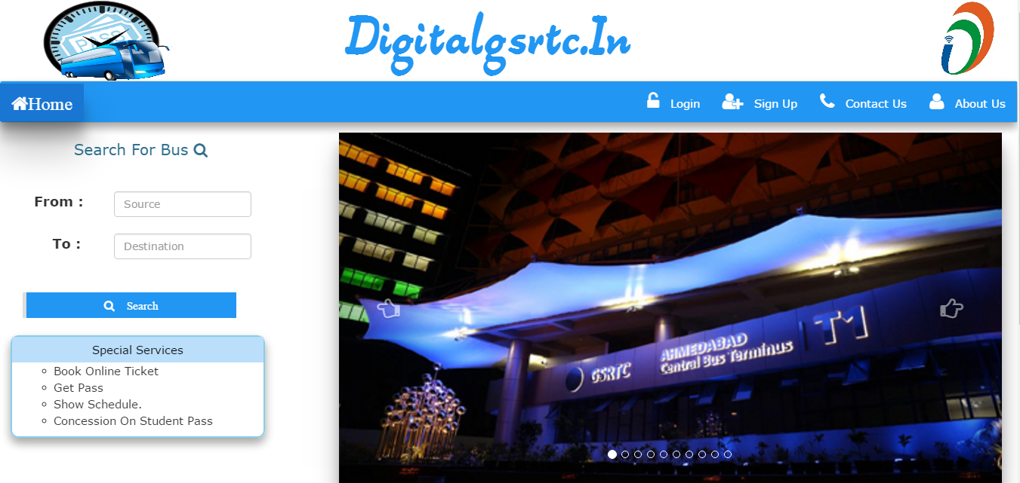

**User Signup Form:**

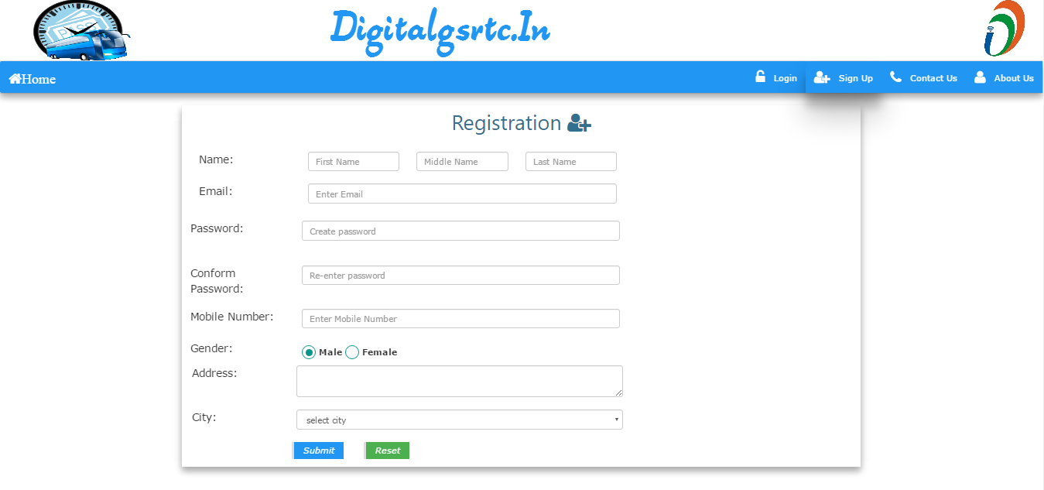

**Login Page:**

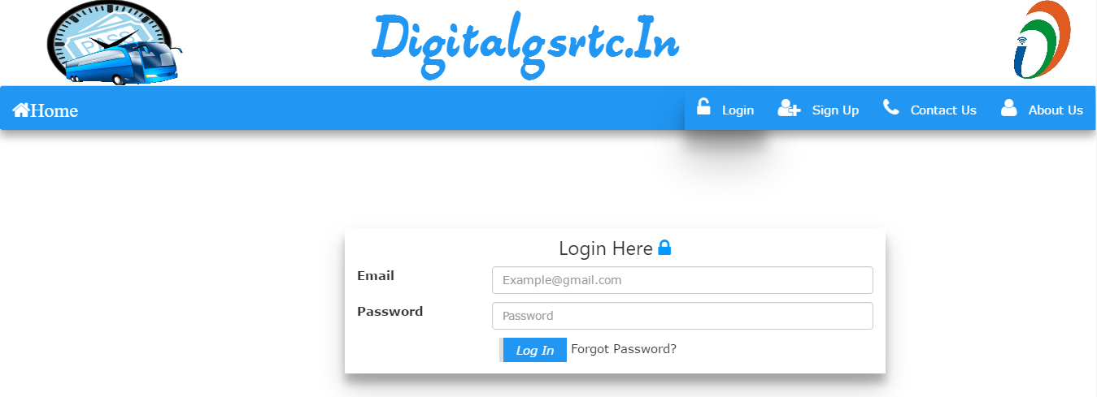

**Home Page of User:**

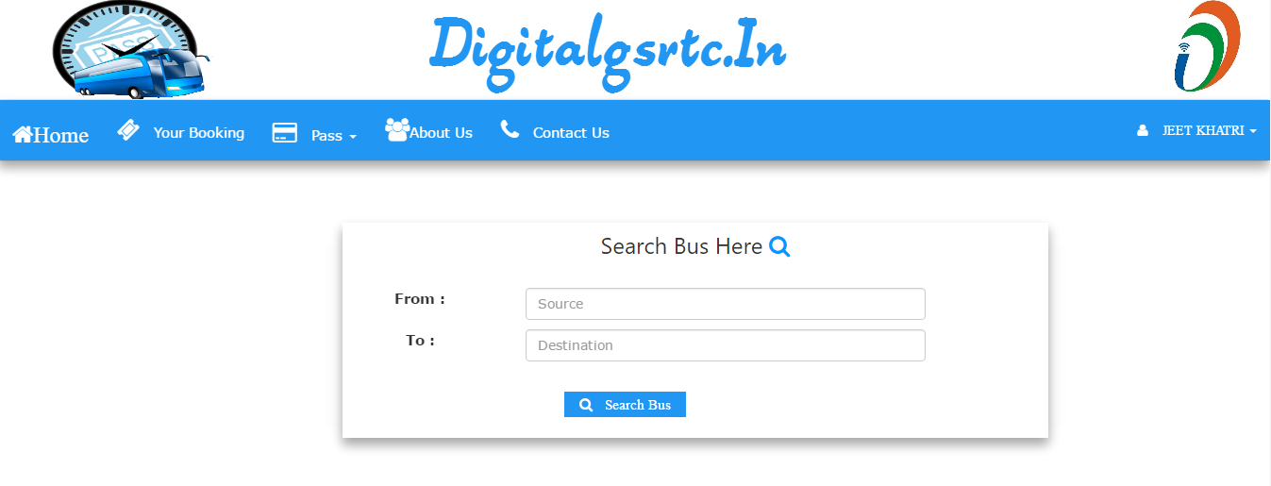

**User can Search Schedule and Book Ticket**

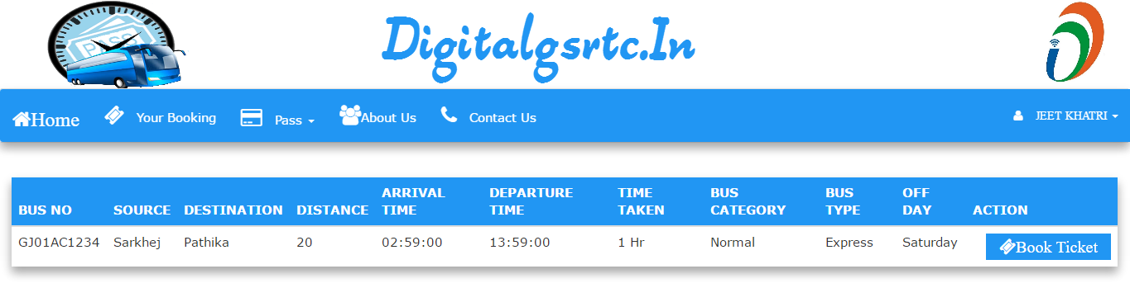

**Select Number of Seat and date:**

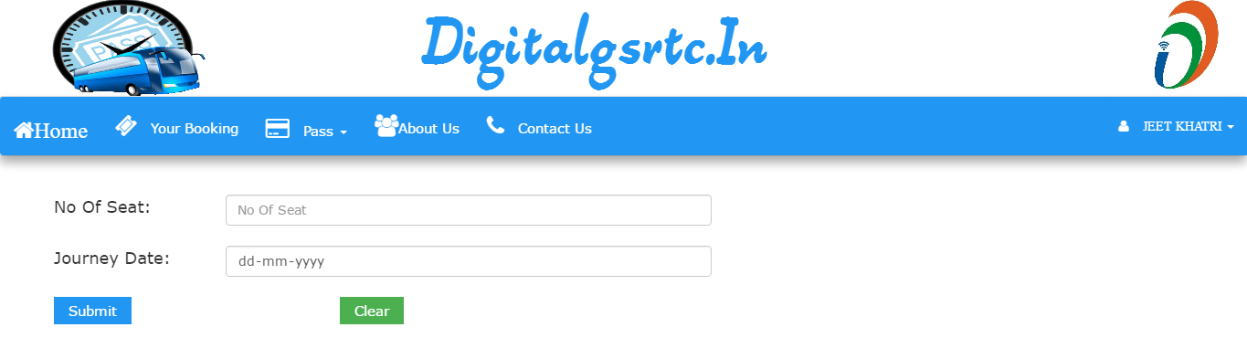

**User Can Choose Particular Seat/s:**

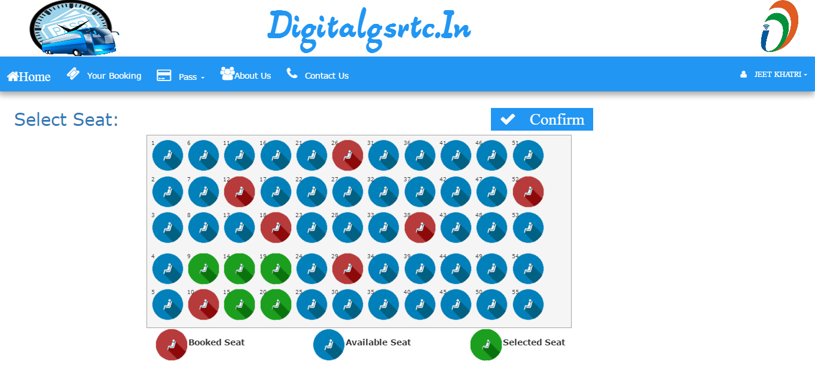

**Users also cancel Ticket and Update, Print Ticket:**

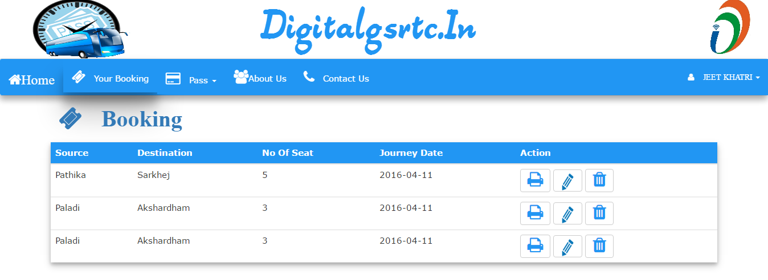

**New Pass Form:**

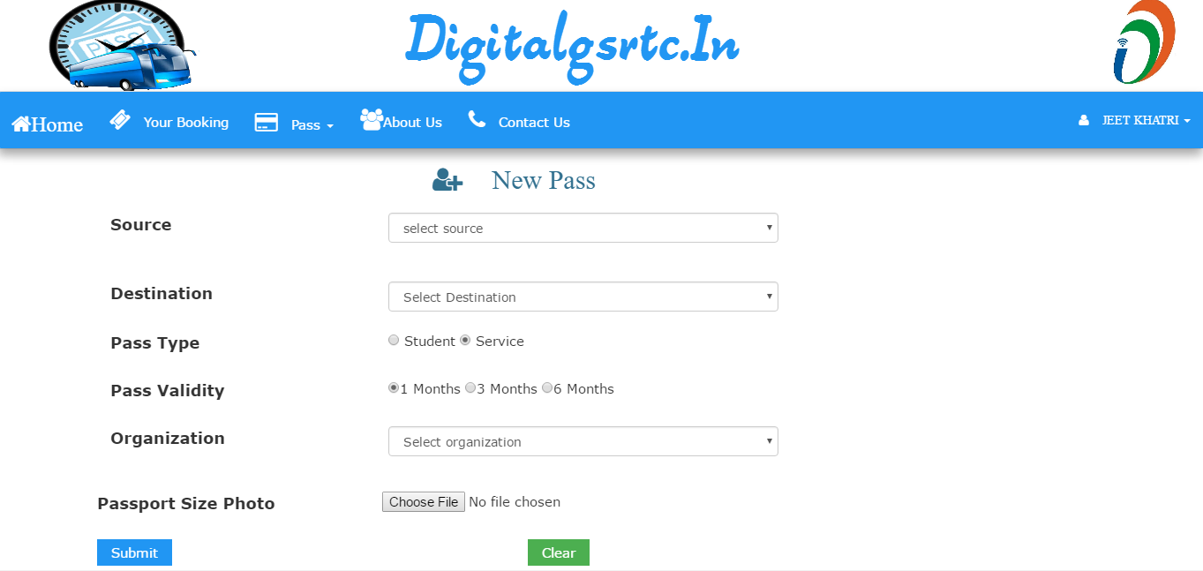

**Confirmation of Pass:**

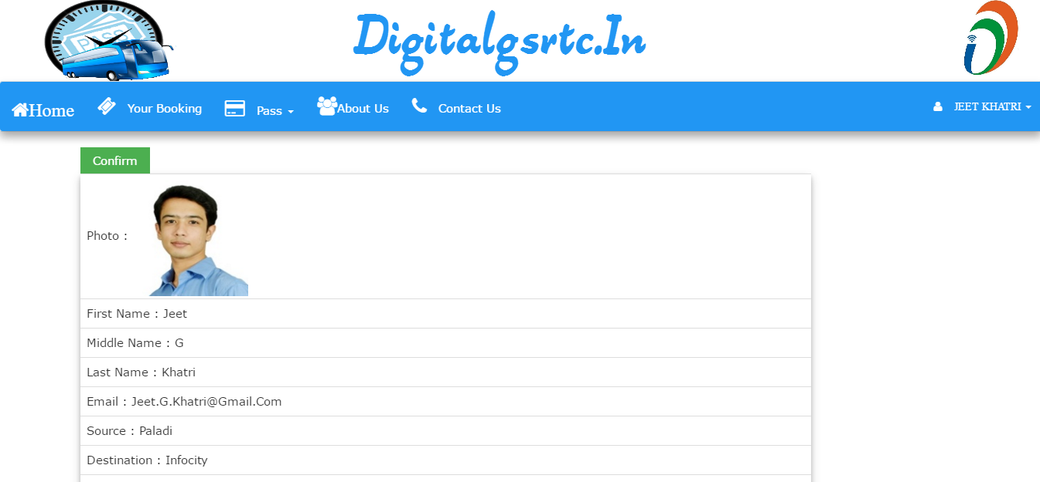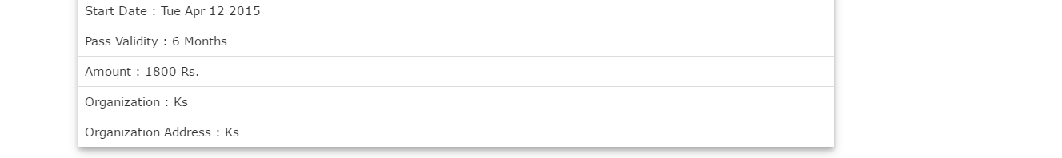

**Edit Profile Page:**

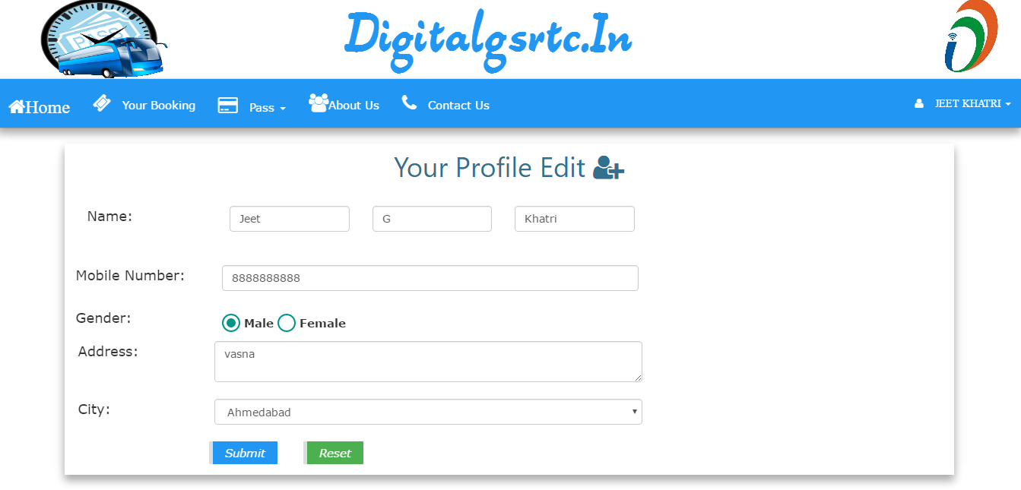

**Change Password:**

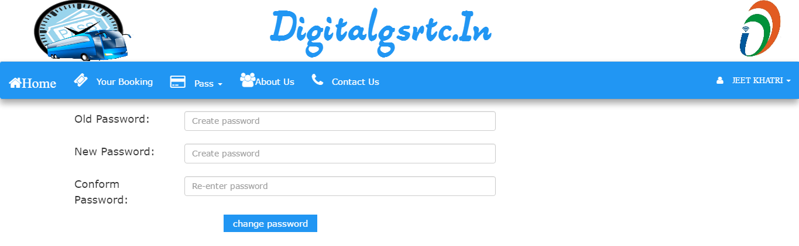

**Print Pass:**

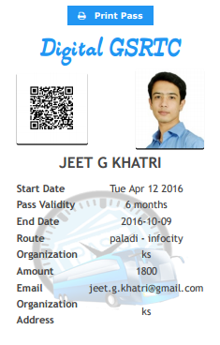

**Print Ticket:**

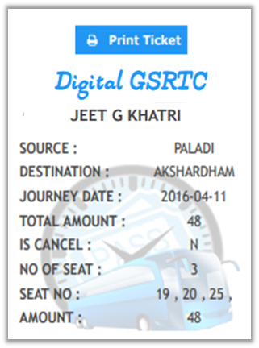

**Feedback Page:**

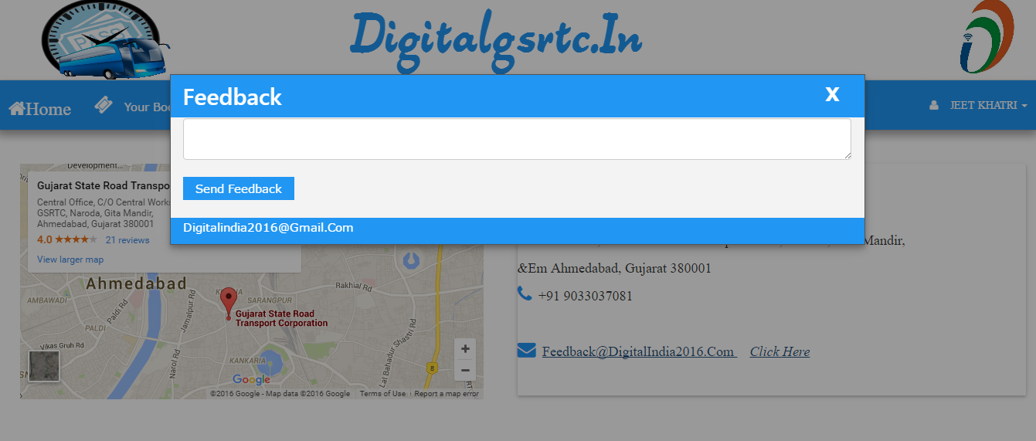

**Forget Password:**

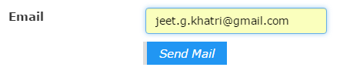

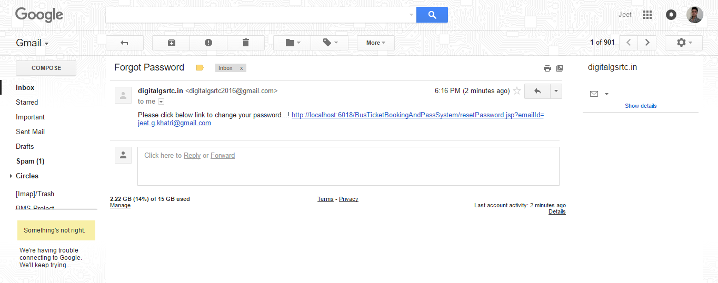

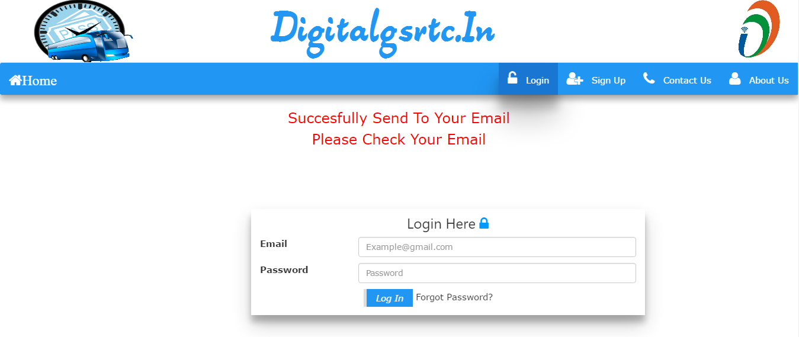

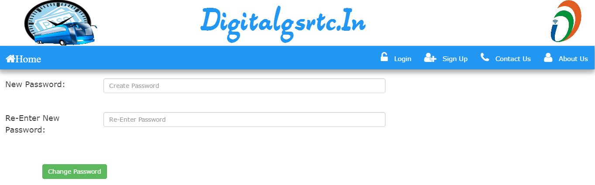

**Contact Us**

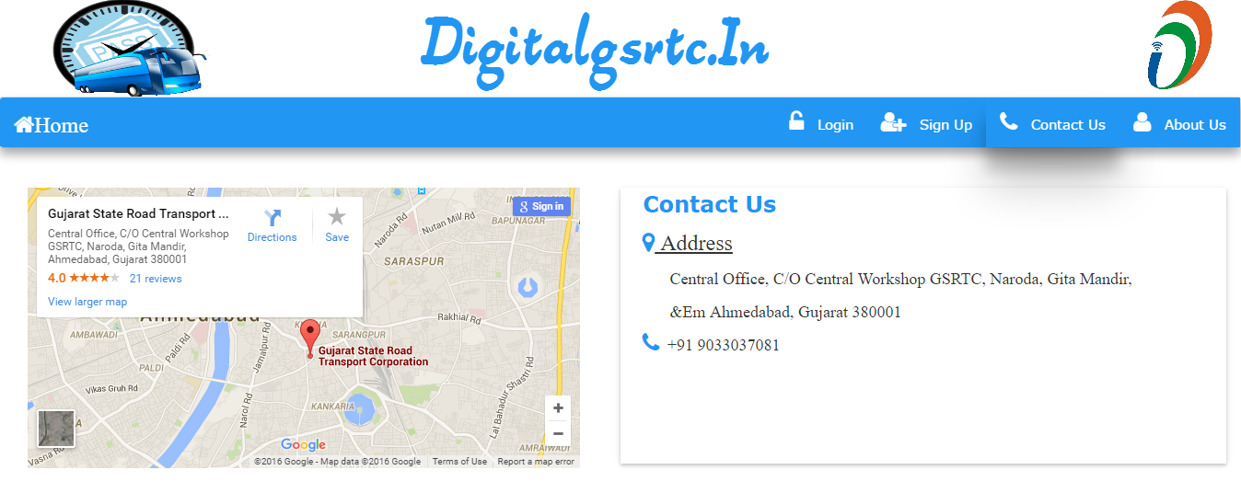

**Admin Penal:**

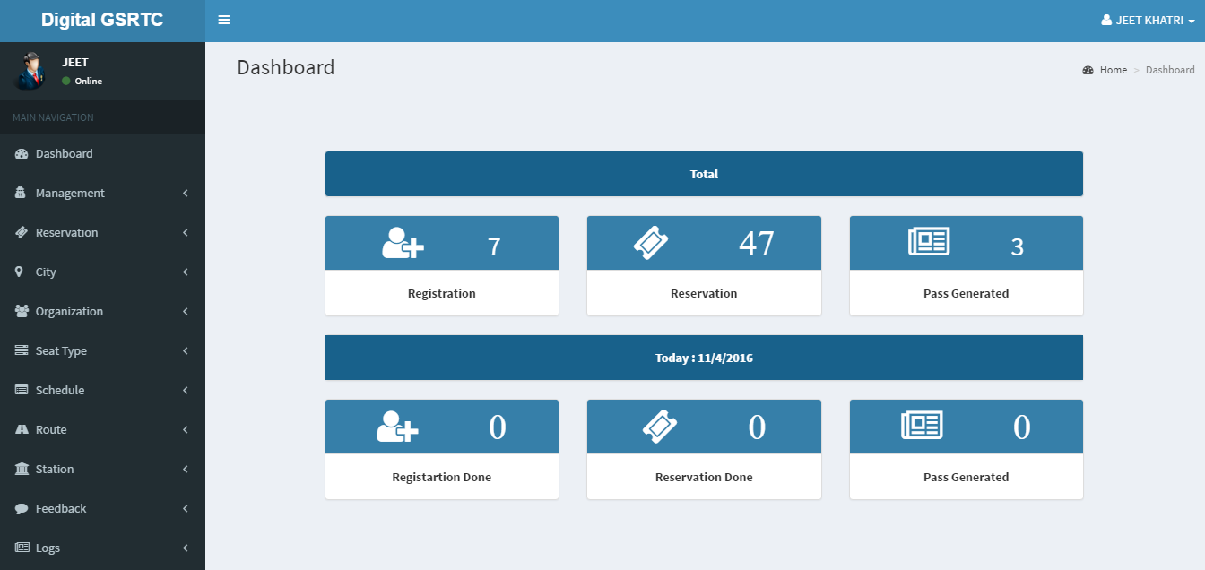

**Add Admin:**

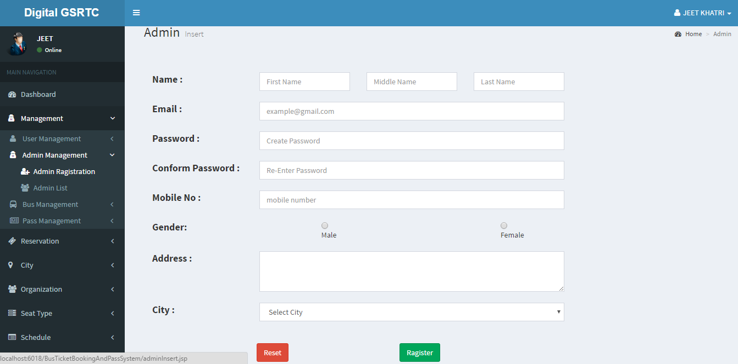

**Change Password:**

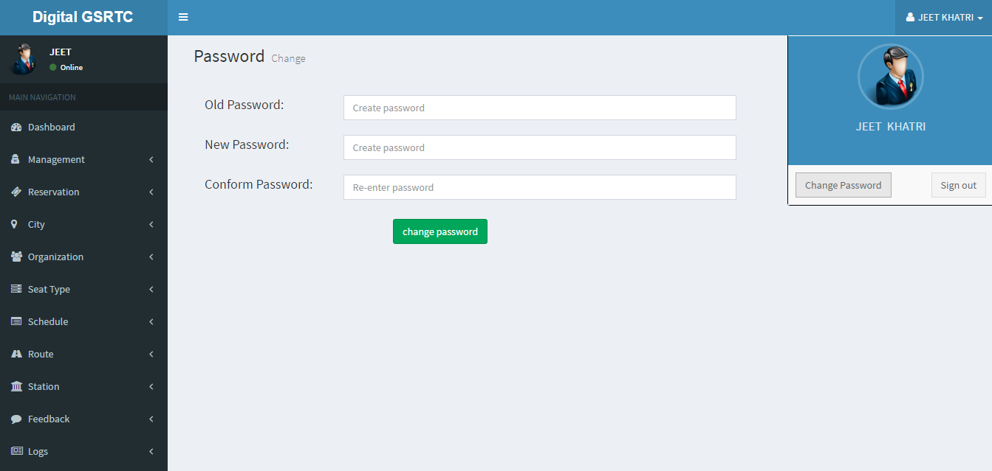

**Add Pass:**

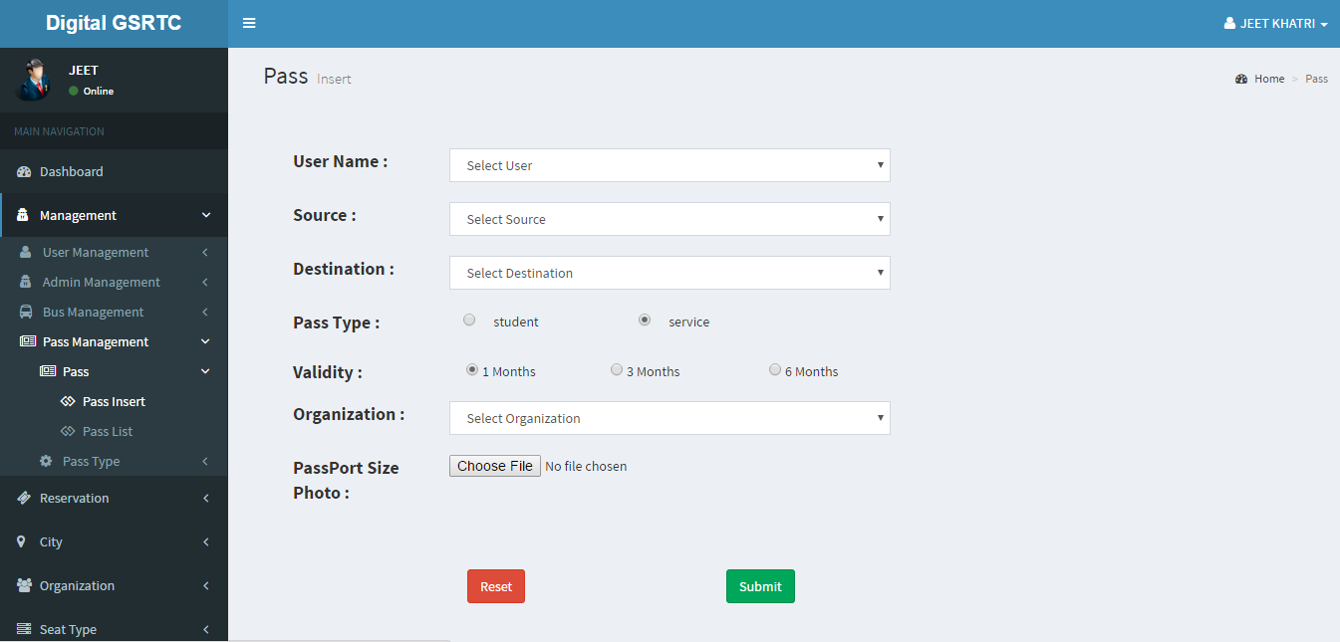

**Add Schedule:**

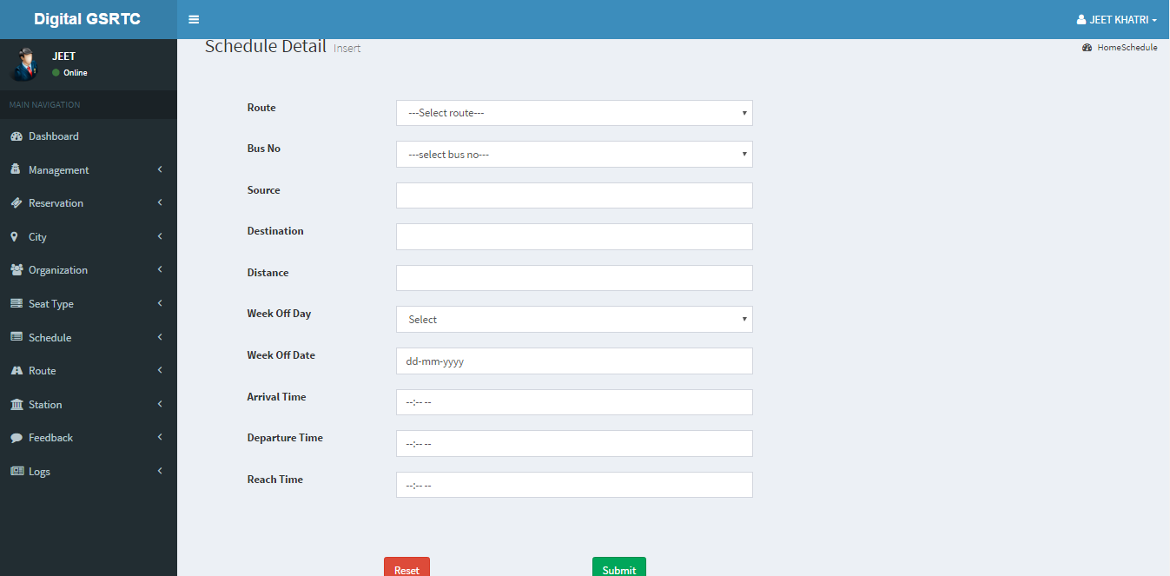

**Pass List:**

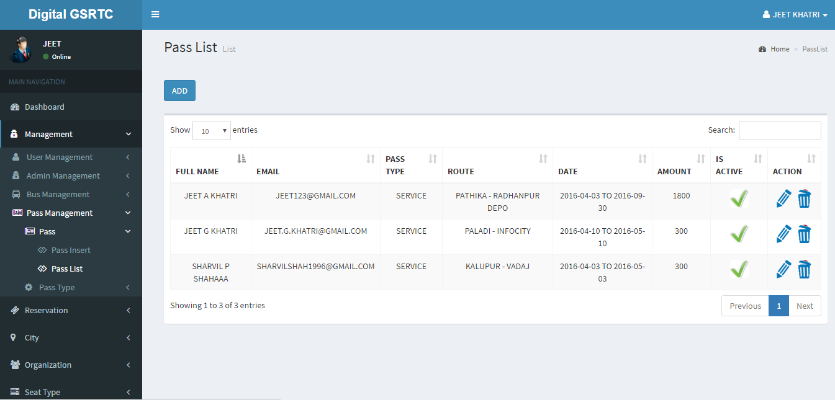

**User List:**

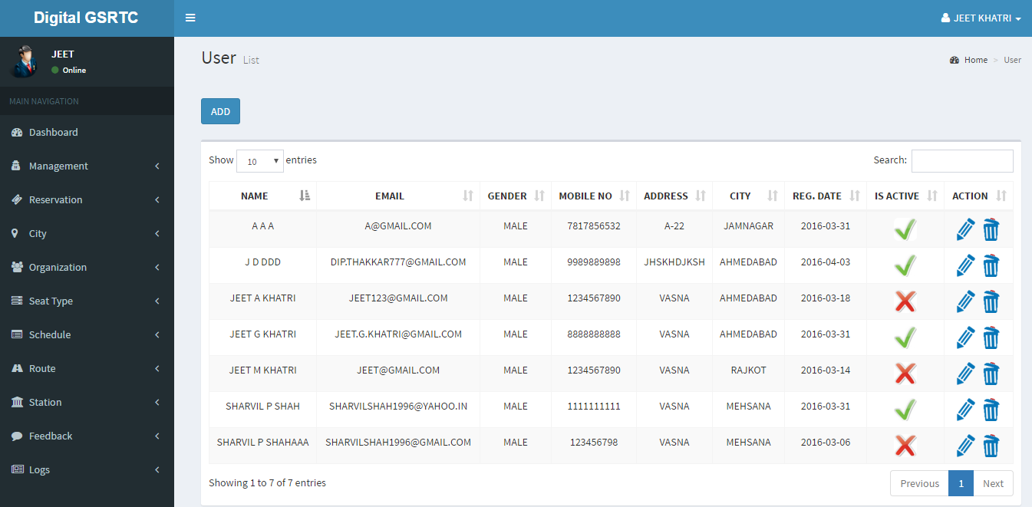

**Log:**

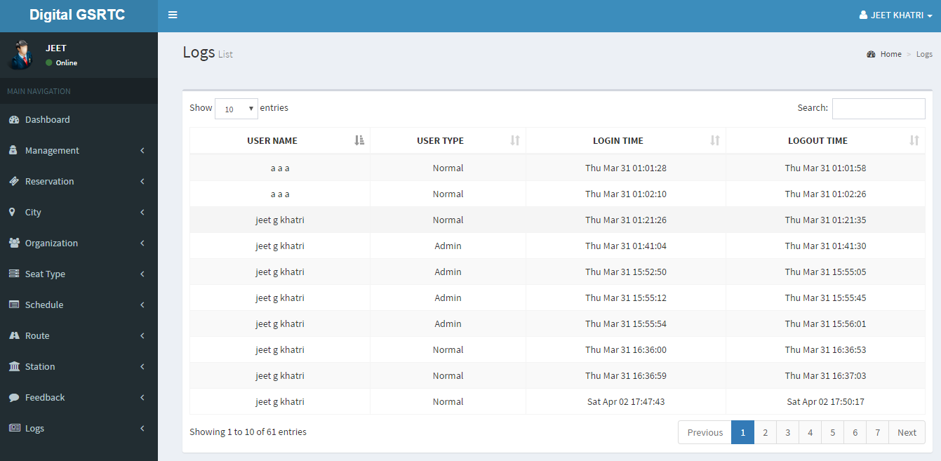

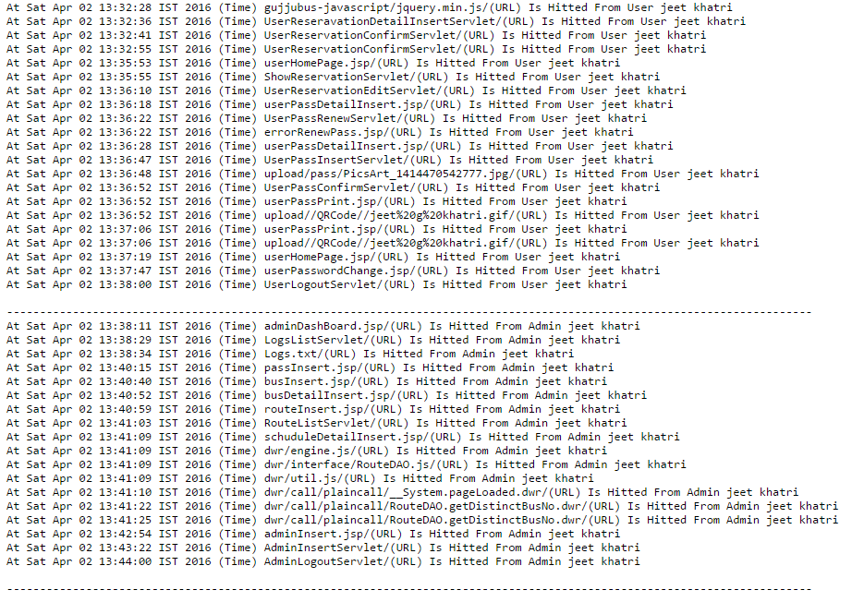

**Testing**

**6. Testing**

System Testing

* Testing for this system deals with concept of updating the data in the right place and the correct destination.
* As decided the Admin would be able to add new Member, Trainer & also More Information and later on edit and thereby update these information.
* If this is achieved then the system has said to be working accurately and the test results do not have any errors.
* Otherwise too, the users should be able to edit the specified his data and can post Data in Database.
* System testing is critical element of application quality assurance and represents the Ultimate Review of specification, design and coding. The main objective of testing is
  + - Testing is a process of executing a program with the intent of finding an Error.
    - A good test case is one that has high probability of finding an as- yet undiscovered error.
    - A successful test is one that uncovers an as – yet undiscovered Error.

Testing Strategy

* **Black box testing**

Black box testing is conducted at the application interface. It is used when the functional operations of the application are to be tested. Knowing the specified function that the application has been designed to perform, tests were conducted that demonstrated that specific functions are fully operational while at the same time searching for errors. It was used to demonstrate input is properly accepted and output is correctly produced.

* **White box testing**

White box testing is predicated on close examination of procedural detail. Here the limited numbers of important logical paths are defined, test cases were developed to exercise logical paths and results were evaluated to ensure their validity.

Validation:

* Weather the String is null or not.
* Weather the String is exist in the system.
* Weather the Email-Id is Valid Or Not.
* Weather the String is Numeric or Alphanumeric or only alphabets.

**Index Validation**

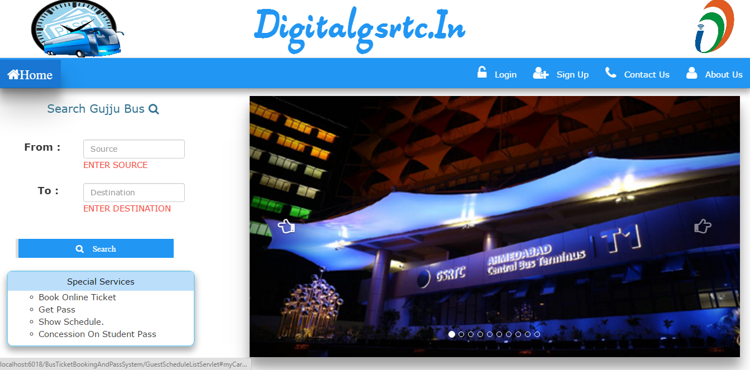

**Validation in Change Password:**

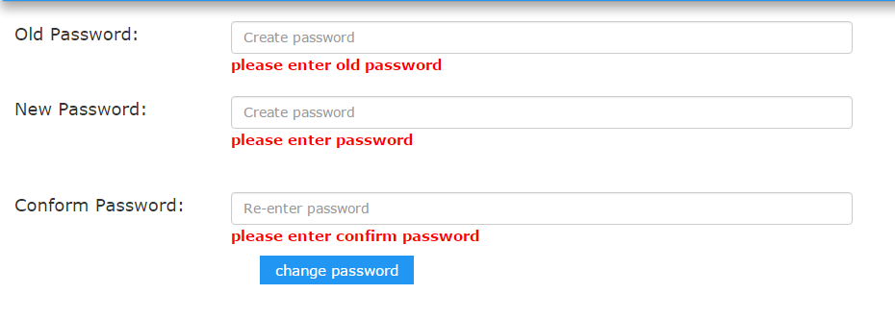

**Validation in Change Password:**

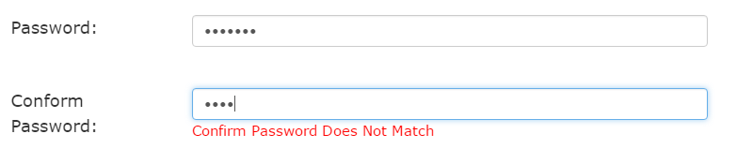

**Validation in Email:**



**Login Validation**

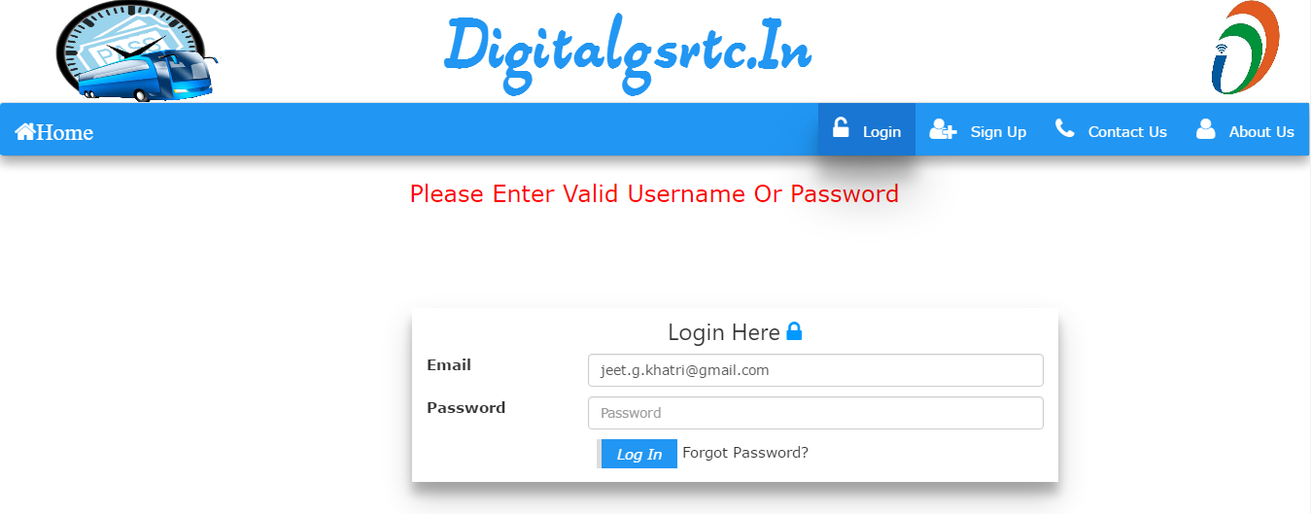

**Validation Reservation**

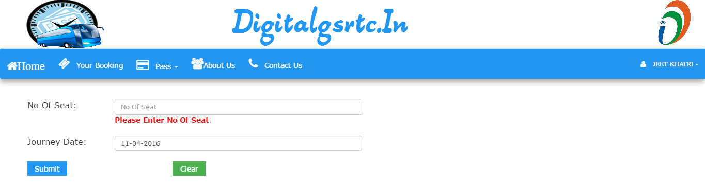

**Validation in Pass Form:**

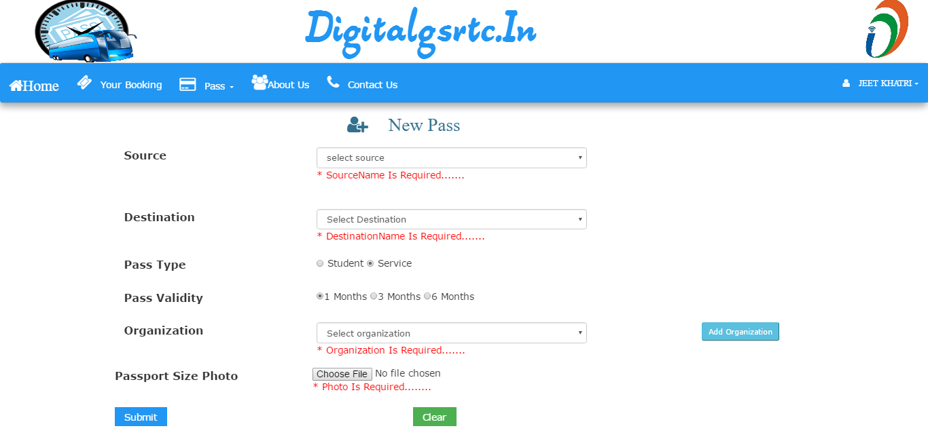

**Validation in Seat Booking**

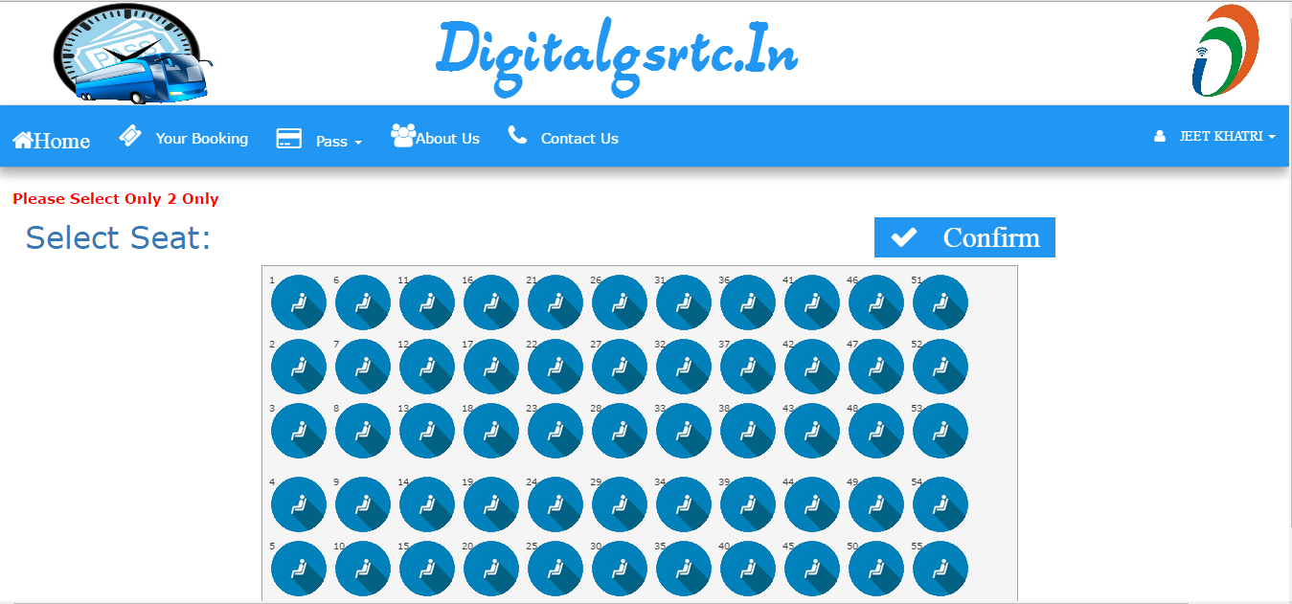

**7. Future Scope**

* Our Current system does not provide Waiting Facility
* We will Provide Online payment

**8. Conclusion**

***Any Work may not always be perfect*:**

­­­­­­­There may be some defects or errors. We have taken enough care to make the project user friendly and more interactive. Major focus is to generate paper dynamically without leaking of paper.

**9. Bibliography**

**Reference sites**:

* + www.jquery.com
  + www.w3schools.com
  + www.stackoverflow.com

**Thank you…**